S
Product Approval Sheet
产 品 承 认 书
Product  产品类别 |  | 2835 0.2W Red LED
Part Number  产品型号 |  | 2835 Red-9mil
The version number  版本号 |  | A/2
Customer Specification客户规格
Customer Name
客户名称
CCT（K）/WD（nm）  色温（K）/波长（nm） |  | 620-630nm
Color Bin  色区 |  | /
（lm）/（mcd）  光通量（lm）/亮度（mcd） |  | 600-800lm
CRI  显色指数 |  | /
SDCM  色容差 |  | /
Vf（v）  正向电压 |  | 1.8-2.4V
If（mA）  正向电流 |  | 20mA
Remarks  备注 |  | /
SUPPLIER/供应商确认栏 |  |  | CUSTOMER/客户确认栏
Prepared/Date  制作 | Approved/Date  批准 |  | Prepared/Date  制作 | Approved/Date  批准
黄昌佳 | 霍涪

● Features


1．3.5*2.8*0.7mm standard package.
2．Wide viewing angle.
3．Suitable for all SMT assembly methods.
4．Pb-free.
5．RoHS compliant.
6．Lens Appearance: clear.

● Applications
1．General lighting
2．Indicators
3．Illumination

● Package Dimensions
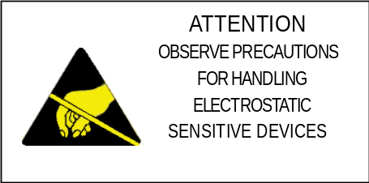
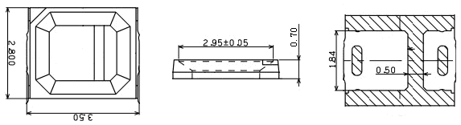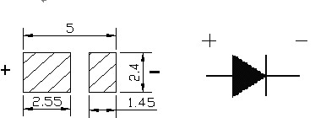

Notes:
- All dimensions are in millimeter.
- Tolerance is ±0.1
- mm unless otherwise noted.
● Absolute maximum ratings at Ta=25℃
Note: Ifp conditions with pulse width ≤10ms and duty cycle ≤10%
Parameter | Symbol | Absolute Maximum Rating | Unit
Forward Current | If | 20 | mA
Pulse Forward Current | Ifp | 100 | mA
Reverse Voltage | VR | 5 | V
Power Dissipation | PD | 144 | mW
Operating Temperature | Topr | -30~+85 | ℃
Storage Temperature | Tstg | -40~+100 | ℃
Junction Temperature | Tj | 115 | ℃
Solder Temperature | Ts | Reflow Soldering ：260℃ for 10sec .  Hand Soldering ：300℃ for 3 sec .

● Electro-Optical Characteristics (TSoldering=25℃)
Parameter | Symbol | Value |  |  | Unit | Condition
Parameter | Symbol | Min. | Typ. | Max. | Unit | Condition
Forward Voltage | VF | 1.8 | 2.2 | 2.4 | V | If=20mA
Dominant wavelength | DW | 620 | -- | 630 | nm | If=20mA
Luminous Flux | IV | 600 | -- | 800 | lm | If=20mA
Thermal resistance | Rth | -- | 33 | -- | ℃/W | If=20mA
Color Rndering Index | Ra | -- | -- | -- | --- | If=20mA
Viewing angle | 2θ1/2 | --- | 120 | --- | Deg | If=20mA
Reverse Current | IR | --- | --- | 10 | uA | VR=5V

Notes: Tolerance of Luminous Flux 10%；
Tolerance of Forward Voltage (VF) ±0.1V；
Tolerance of Wavelength (X,Y) ±0.01（CCT±5%）；
Tolerance of Color Rndering Index (CRI) ±2；
Tolerance of Dominant wavelength ±1；

● Typical Optical-Electrical Characteristics curves
( Environment Parameter： Temperature=25℃， Humidity=45%)
Relative Flux VS Forward Current

Forward Current VS Forward Volatage

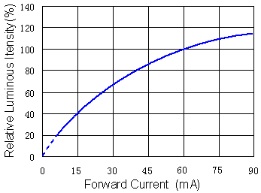
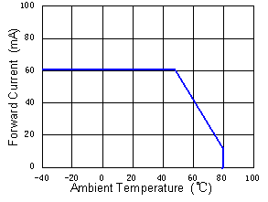
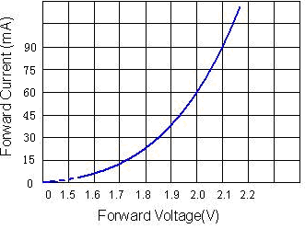

Relative Flux VS Ambient Temperature
Forward Curent VS Ambient Temperature

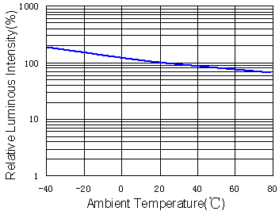

Relative Spectral Distribution
Typical Spectral Distribution

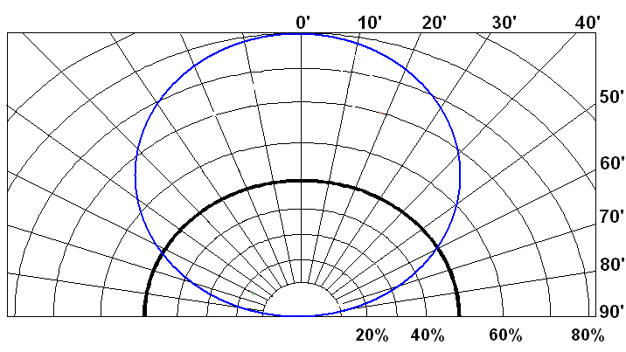
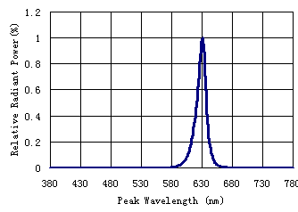

● Reliability Test
Test Item | Test Conditions | Continuous cycle | Result | Reference Standard
Temperature  Cycling | -40℃ 30min  ↑↓25℃(5min)  100℃ 30min | 100 cycle | 0/22 | JESD22-A104
Thermal Shock | -40℃ 30min  ↑↓  100℃ 30min | 100 cycle | 0/22 | JESD22-A106
High  Temperature  Storage | Ta=100℃ | 1000 hours | 0/22 | JESD22-A103
Low  Temperature  Storage | Ta=-40℃ | 1000 hours | 0/22 | JESD22-A119
Operation Life | Ta=25℃  IF=60mA | 1000 hours | 0/22 | JESD22-A108
High Humidity Heat  Life Test | 60℃ RH=85%  IF=60mA | 1000 hours | 0/22 | JESD22-A101
Solder  Resistance | 260℃(Max.), within 10seconds. (Max.) | 3 times | 0/22 | JESD22-B106

● Judgment criteria of failure for the reliability
Item | Symbol | Condition | Judgment criteria for failure
Forward voltage | VF | IF=20mA |  | USL×1.1
Reverse current | IR | VR=5V |  | 10uA
Luminous Flux | Ф | IF=20mA | LSL×0.7

[Note]:
*1 USL: Uper Specification Level
*2 LSL: Lower Specification Level

● Packaging Specifications
Dimensions of Tape (Unit: mm)
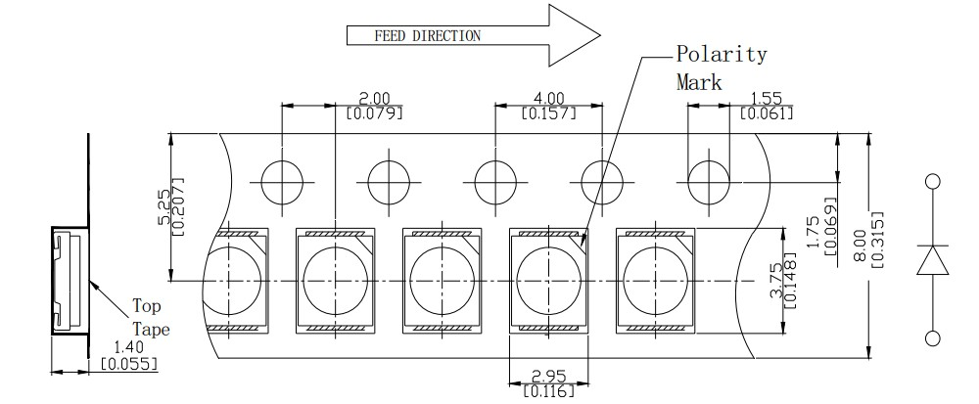
Dimensions of Reel (Unit: mm)
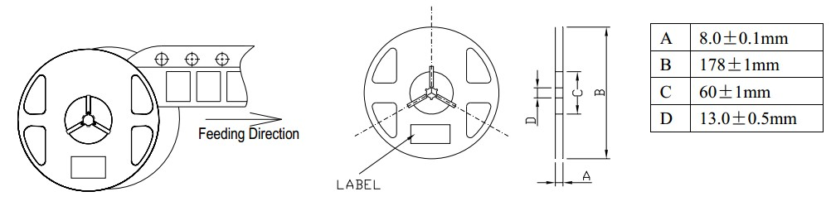

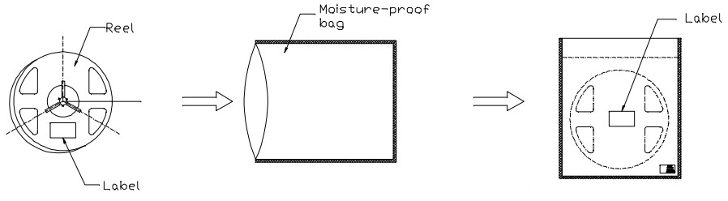
NOTES：
1. Tolerance unless mentioned is ±0.1mm; Unit = mm；
2. The maximum number of missing lamps is two;
3. The cathode is oriented towards the tape sprocket hole in accordance with ANSI/EIA RS-481 specifications.
4. 4,000 pcs/ Reel.

● Reflow profile
Soldering condition
●Recommended soldering conditions
Reflow |  | Soldering
Pre-heat | 160～180℃ | Temperature  Soldering time | 300℃Max.  3 second Max.  (one time only)
Pre-heat time | 120 seconds Max. | Temperature  Soldering time | 300℃Max.  3 second Max.  (one time only)
Peak temperature | 260℃Max. | Temperature  Soldering time | 300℃Max.  3 second Max.  (one time only)
Soldering time | 10 seconds Max. | Temperature  Soldering time | 300℃Max.  3 second Max.  (one time only)
Condition | Refer to Temperature-profile | Temperature  Soldering time | 300℃Max.  3 second Max.  (one time only)
●After reflow soldering rapid cooling should be avoided
Pb-free solder temperature profile
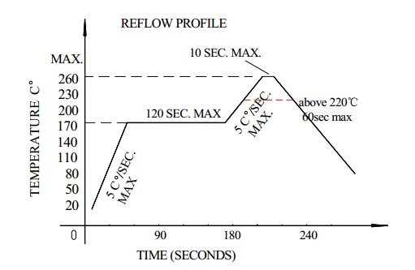

1. We suggest that the reflow soldering temperature is 240±5 ℃, the highest control the welding temperature to 260 ℃；
2. Reflow soldering should not be done more than two times；
3. When soldering ,do not put stress on the LEDs during heating；
Soldering iron
1. When hand soldering, keep the temperature of the iron under 300℃, and at that temperature keep the time under 3 sec；
2. The hand soldering should be done only a time；
3. The basic spec is ≤5 sec. when the temperature of 260℃, do not contact the resin when hand soldering；
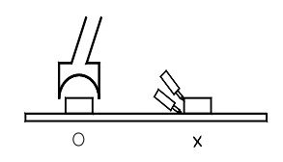
Rework
1. Customer must finish rework within 5 sec under 260℃；
2. The head of iron can not touch the resin；
3. Twin-head type is preferred；

● CAUTIONS
Storage
1. Storage condition before opening the package: 5℃~30℃, the largest percentage relative humidity is 60%
and the storage period is one month. The LEDs beyond the storge period just can be used after dealing as
step 4.
2 .After opening the package, If the LEDs will be Infrared reflow soldering, Oxygen phase reflow soldering
or any other welding.
a. must be welding within 24 hours.
b. the storage humidity must be below 30%.
3 .If the situation does not satisfy 2a or 2b, the LEDs must be roasted.
4 .If the LEDs need to be roasted, the roast temperature should be 60℃+/-3 and the roast timeshould be 48
hours.
ESD
Static Electricity or power surge will damage the LED.
The following procedures may decrease the possibility of ESD damage:
1.All production machinery and test instruments must be electrically grounded.
2.Use a conductive wrist band or anti-electrostatic glove when handling these LEDs.
3.Maintain a humidity level of 50% or higher in production areas.
4.Use anti-static packaging for transport and storage.
Cleaning
1.Led should be cleaned in a normal temperature and the time for cleaning should be less than 3 minutes ;
please use Alcohol as cleaner ,before you use other cleaning solvent ,please make sure that the cleaner will
not make any damage to the LED performance or the appearance .
2.Ultrasonic Cleaning is also commonly used for cleaning LED , please verify the Ultrasonic cleaning ’s
Power and time to avoid any damage to the LED .
The recommended solvent for cleaning
Common cleaning solvent  常用清洁溶剂 | Disable cleaning solvent  禁用清洁溶剂
Alcohol酒精 | Thinner、Acetone、Two fluorine resin 、  Acetone b dilute  稀释剂、丙酮、 二氟脂、三氯乙稀
Handing Precautions
Compare to epoxy encapsulant that is hard and brittle,silicone is softer and flexible.Although its characteristic significantly reduces thermal stress,it is more susceptible to damage by external mechanical force.
As a result,special handling precautions need to be observed during assembly using silicone encapsulated LED products.Failure to comply might leads to damage and premature failure of the LED.
1. Handle the component along the side surfaces by using forceps or appropriate tools

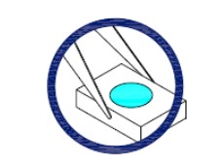

2.Do not directly touch or handle the silicone lens surface.It may damage the internal circuitry.
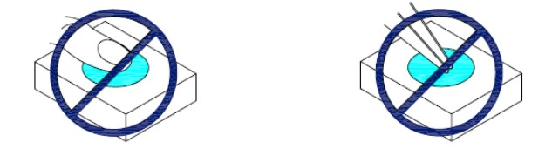

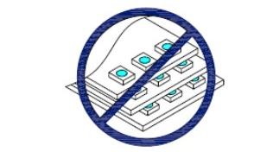
3.Do not stack together assembled PCBs containing exposed LEDs.Outside impact may scratch the silicone lens or damage the intemal circuitry.

4.During surface-mounting,the pickup capillary diameter should be larger than the silicone lens to insure the capillary does not scratch or damage the lens.
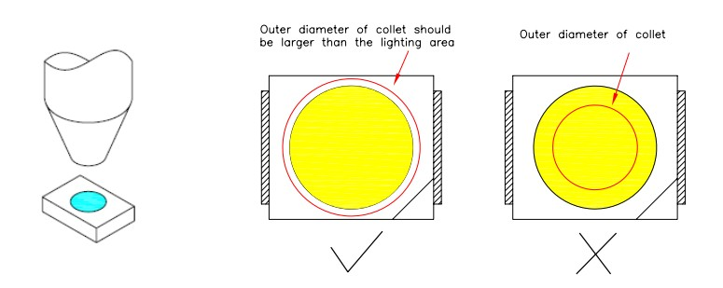

5.LED operating environment and sulfur element composition cannot be over 100PPM in the LED
mating usage material.（ LED工作环境及与LED适配的材料中硫元素及化合物成份不可超过100PPM）

6.When we need to use external glue for LED application products, please make sure that the external glue matches the LED packaging glue. Additionally ,as most of LED packaging glue is silica gel,and it has strong Oxygen permeability as well as strong moisture permeability; in order to prevent external material from getting into the inside of LED, which may cause the malfunction of LED, the single content of Bromine element is required to be less than 500PPM,the single content of Chlorine element is required to be less than 500PPM,the total content of Bromine element and Chlorine element in the external glue of the application products is required to be less than 1000PPM. Other points for attention, please refer to our LED user manual.

